## **ECE Capstone Design Course –**

## **Outline for Project Proposal / Development Plan**

## 1. Introduction

## In response to the urgent need for enhanced predictive models in meteorology, we have chosen to develop an advanced system for hurricane cloud detection and path prediction utilizing geostationary satellite imagery. Our motivation for this project was to create a more accurate hurricane tracking model to ensure that disaster areas being affected by tropical storms could be warned in advance about the hurricane’s path. As background, we are utilizing several satellites and their respective datasets to teach our model’s cloud masking and hurricane tracking capabilities. These would likely include the NOAA, Sentinel-2, and Landsat 8 satellites with possibly more in the future depending on our model’s learning requirements. These instruments provide us with a rich tapestry of data ranging from thermal signatures to cloud composition, all of which would distinguish and track hurricane patterns with unprecedented precision.

## With this project, we aspire to transcend traditional methods by implementing machine learning algorithms that learn from historical datasets. Through the use of motion analysis, we plan to create backgrounds from frames across different days of the year grouped according to features such as time of day and season. Such methods would essentially be the incorporation of computer vision into our cloud tracking and learning literature. By combining already established scientific research in cloud detection alongside machine learning computational techniques, we hope to create accurate predictions for tropical storms that can be useful in emergency scenarios.

## 2. Related (prior) art

A geostationary satellite is launched to an altitude of about 22,000 miles above the equator, creating an orbit that matches the speed at which the planet rotates. These satellites are able to sense electromagnetic energy on different wavelengths (bands), each falling into one of three categories:

1. Visible
2. Near-Infrared
3. Infrared

While searching for methods used to identify/map clouds in images, we came across examples which utilize the open-sourced toolbox developed for sentinel 2 and the google earth engine. One such project was written by Minh Nguyen, the results of which can be seen in fig 1. These examples will be useful in the development of our own mapping algorithms, the only difference being that we will be selectively mapping tropical storms. Being able to identify and map onto the selected cloud formations will allow us to train our model on storm behavior and have it predict missing and future data.

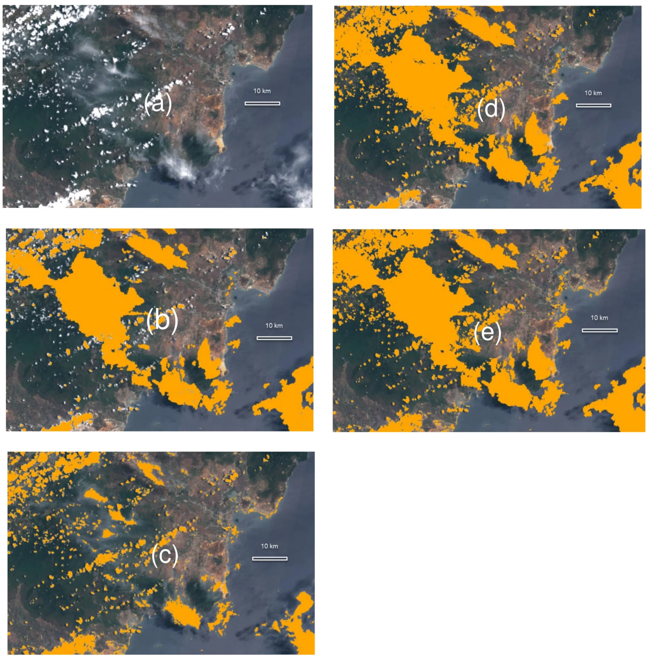

Figure 1: Sentinel 2 cloud mapping over google earth engine.

The topic of background subtraction as a method to mask clouds was brought to our attention by our professor and TA’s. While looking into the possibility, we found a method proposed by Satrughan Kumar which uses background modeling to extract the foreground, and tracks the objects using Kalam filtering. To extract the foreground, initial empty frames are averaged together to form a reference background. Unless the work has already been done and is publicly available, in order to perform this method of extraction and tracking, we would need to stitch together cloudless parts of many images to build our initial frames. We would also need to create reference photos for the many different times of day and for each season.

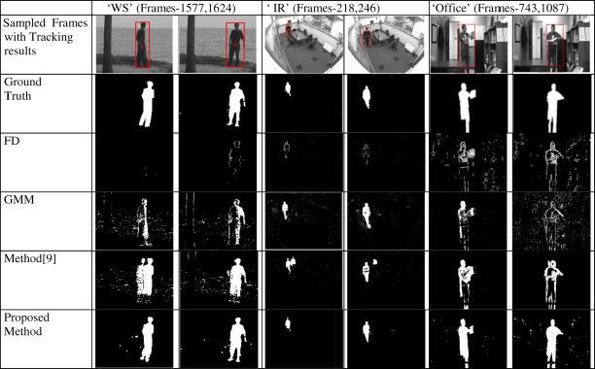

Figure 2: Satrughan Kumar’s visual comparison of foreground motion masks

In order to distinguish tropical storms from other weather patterns, we learned that hurricanes can be easily identified by their shapes and temperatures. Hurricanes take shapes from ovals to circles (the stronger they are, the more symmetrical they become). The eye of a hurricane is the point about which the storm rotates, this area is another key identifier of a hurricane and its intensity. At a certain strength in cyclones, due to the coriolis effect, the eye is empty of clouds and the area experiences relatively mild conditions. Additionally, the temperature of cloud formations can be used to identify a hurricane. An inner ring of cold cloud temperatures which progressively get warmer as you move away from the eye is a distinctive feature of cyclonic weather.One way which we would be able to obtain temperature data on cloud formations would be by using the GOES R ABI band 11 which shows cloud top temperatures as seen in fig 3.

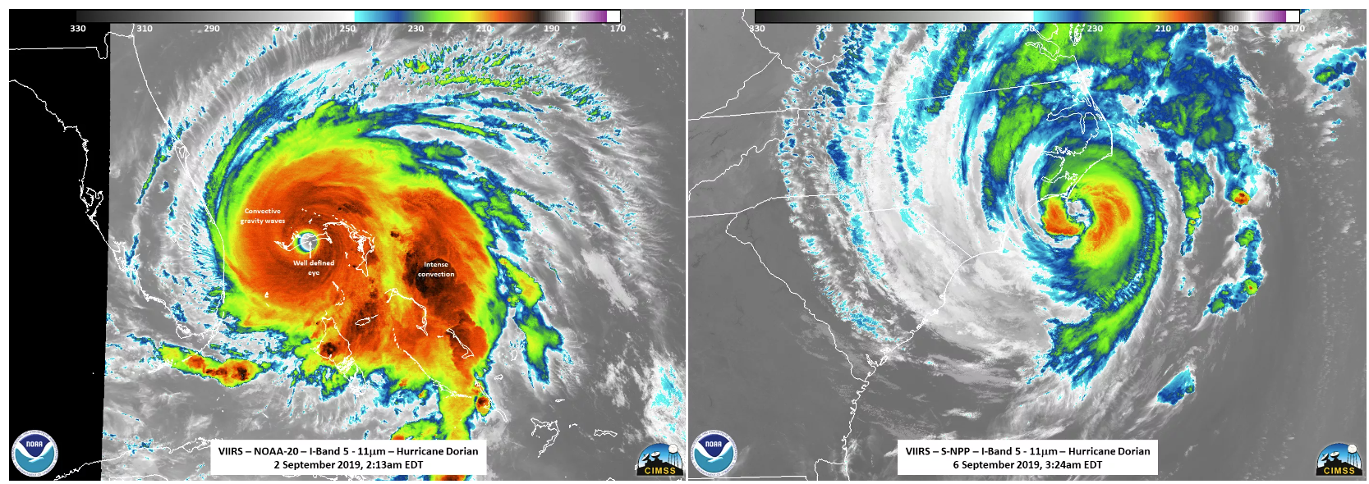

Figure 2: Images and temperature readings of Hurricane Dorian on 09/02/2019 and 09/06/2019

One way which we would be able to obtain temperature data on cloud formations would be through using the GOES R ABI band 11 which depicts cloud top temperatures as seen in fig 3.

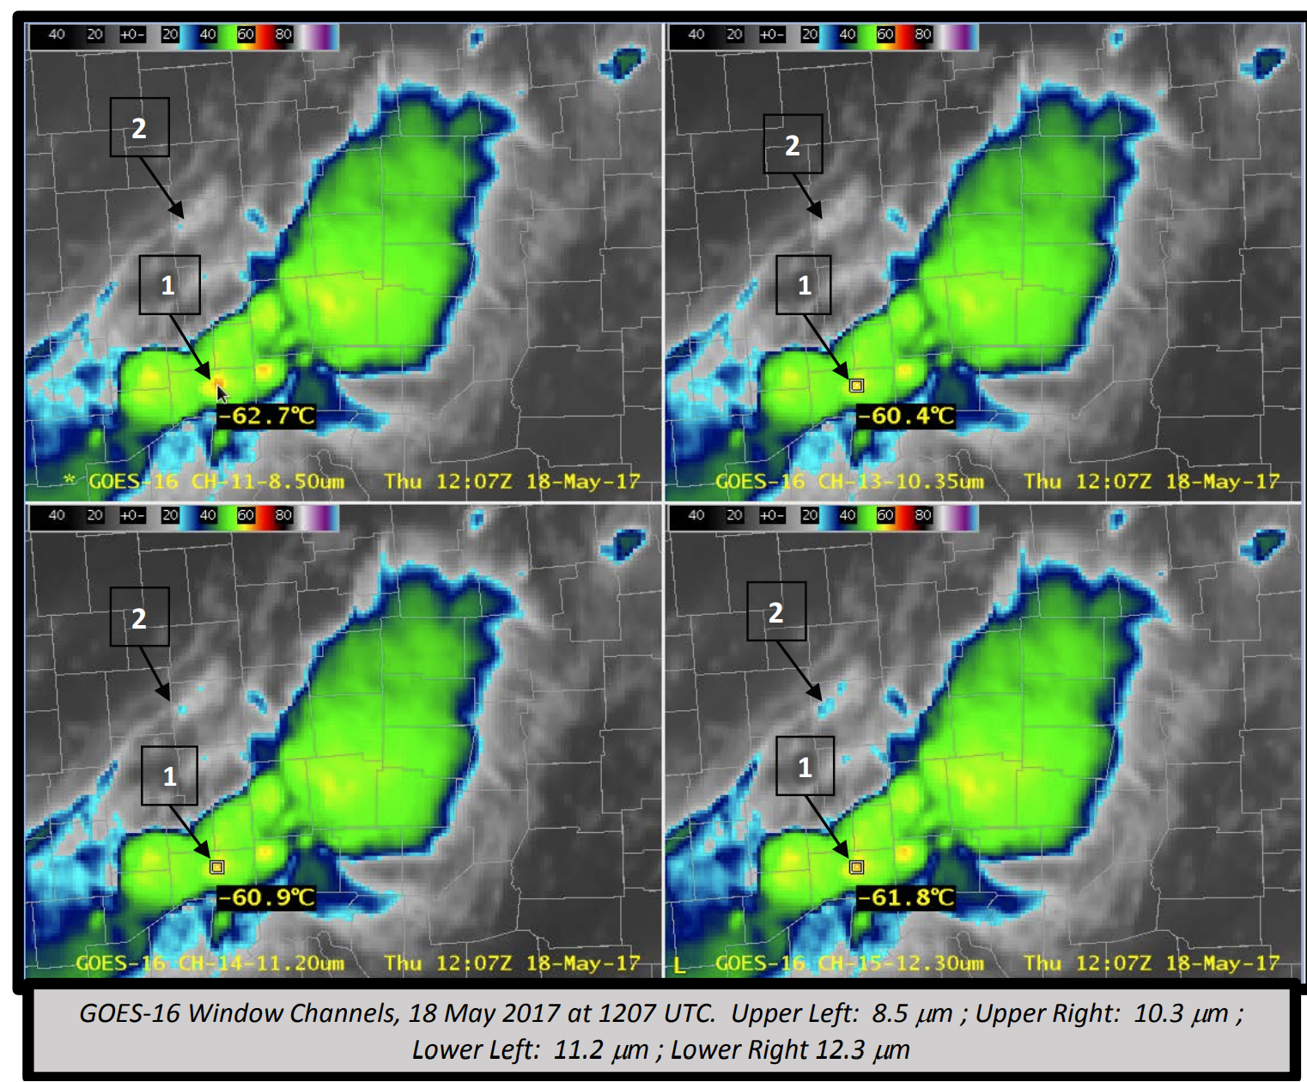

Figure 3: GOES R ABI band 11 imagery from provided documentation

The three datasets we are currently focusing our attention on are NOAA’s GOES R, ESA’s Sentinel 2, and NASA’s Landsat 8 databases. Each of these programs launched numerous satellites which have been capturing imagery across multiple spectral bands for several years.

## 3. Project scope and major ideas/functionalities

* Cloud Identification
  + Background Subtraction
    - Create/Obtain cloudless mosaics of land and sea area at different times of day and of different seasons
    - Remove background from input imagery by referencing the mosaics, effectively creating a cloud mask
  + Cloud Mask Creation
    - Create an effective cloud mask to identify clouds in geostationary satellite images, specifically using Sentinel-2 and Landsat-8 satellite data.
    - Utilize Sentinel-2’s QA60 mask for cirrus and opaque cloud detection
    - Employed Landsat-8’s thermal infrared sensor for detecting non-cirrus and non-opaque clouds for full coverage
* Tropical Storm Identification
  + Improve the model by adding features and thresholds specific to tropical storms
  + Use NOAA satellite data to identify crucial elements
  + Implement algorithms to predict the path of hurricanes
* Major Ideas
  + Edge detection on clouds
  + Utilization of Google Earth API
  + Integration of Sentinel-2, Landsat-8, and NOAA satellites
  + Training ML models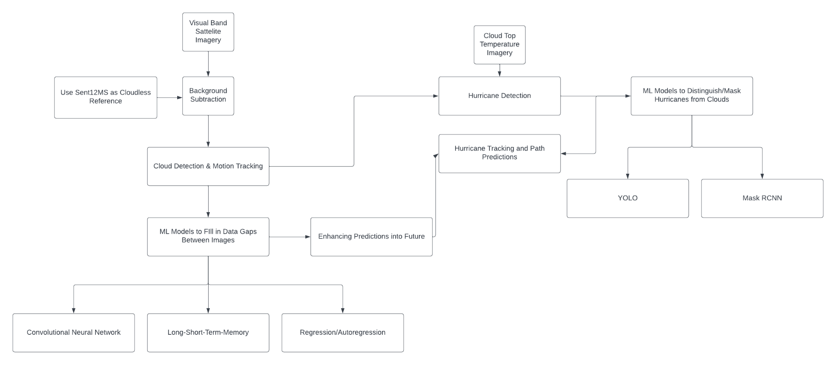

## 4. Main approaches (2-3 alternatives) and data sources etc.

Our main approach and alternative approaches will always begin at the same point: creating an effective cloud mask to detect clouds through remote imagery. Our first approach will be to utilize Sentinel-2 and Landsat-8’s datasets together to train our model. The Sentinel-2’s

QA60 mask would be good for initially determining cirrus and opaque cloud cover, and the Landsat-8 is useful for its thermal infrared sensor. The thermal capabilities of the Landsat-8 would be able to capture non-cirrus and non-opaque clouds that were missing from the Sentinel-2’s cloud mask. After we create an effective cloud mask, we will then begin adding more features and thresholds that are specific to the behavior of a tropical storm. At this point, data from the NOAA satellite will be used more frequently since they have dataset bands specialized towards water vapor, cloud tops, and atmospheric temperature profiles which could be crucial for identifying and tracking any tropical storms. The main differences in approaches will not be in which satellites we use for training, but rather the specific databases in each satellite. As such, our project will have two main phases.

The first phase will be primarily to create an effective cloud mask detection model that will be able to conduct edge detection on any clouds in the image. This is a common first step in any advanced atmospheric-based machine learning model. For our model specifically, we plan to utilize the Google Earth API built in Javascript. The second phase will come after establishing a cloud mask. From there, we will add more training features specific to the attributes of a tropical storm discussed earlier inside the related art section. For this part of training, we plan to utilize primarily NOAA's GEOS satellite and several of its data sets specific to hurricane behavior. The main approach will be to utilize Band 11’s cloud top dataset (which tracks the temperature of the cloud alongside its formation) alongside the Derived Motion Winds dataset to train our model since we predict that the temperature of the cloud alongside the wind behavior of the cloud would be effective classifiers of tropical storms as well as predictors for future movement. The other approaches for training will involve different datasets such as the Band 6 cloud particle and upper-level water vapor which are also important features of tropical storms.

When creating an effective cloud mask, we may use background subtraction for the purpose of cloud segmentation. Geostationary satellite imagery will often include a lot of noise in the form of landmasses, regular weather clouds, and other atmospheric disturbances depending on the image. Background subtraction will be useful in reducing the noise and ensure that the focus is solely on the dynamic changes such as the development and movement of hurricane clouds. Additionally, since geostationary satellites capture images at regular intervals of 10 minutes, background subtraction can be used to track changes over time. By comparing the current imagery with a reference image from some interval (10-20 minutes) ago, it is possible for us to identify the new developments in cloud patterns associated with hurricanes. For effective background subtraction, we will create a set of reference background images based on historical data from images taken at a certain time of day during a certain season. For example, we can compare the images of clouds in January across historical years and use this as the “background” against which our newer images train our model to account for seasonal variations in cloud cover and weather patterns.

Our approach was partly based on Minh Nguyen’s application of the Sentinel-2 data alongside Landsat-8 to calculate cloud cover for the purpose of crop and drought detection. Our approach will apply the similar concept of creating individual masks from both the Sentinel-2 and the Landsat-8 before creating a combined mask involving both. However, our approach will differ in how we will utilize different features within both datasets to ensure that we capture clouds relevant to tropical storm detection only. Our approach for utilizing the NOAA GOES satellites for tropical storm features aside from cloud edges comes largely from the NOAA’s actual guide to understanding hurricane features and extracting relevant information to detect them. From this guide, we plan to modify their approach by extending the model’s capabilities beyond simple detection but also prediction.

After finishing the creation of an effective cloud mask, we will move on to creating a predictive model that will be capable of tracking the storm’s movements. For most models, preprocessing will be a necessary step. We will extract polygon objects from the cloud cover after background subtraction to use in our model’s training. A Long Short-Term Memory (LSTM) network will be used for the project given that they are inherently suited for sequential data. This makes LSTMs suitable for time-series predictions that can capture temporal dependencies related to time of day and season in cloud dynamics, possibly assisting us with more accurate data between snapshots from the satellite.

Alternatives to a LSTM network are available for our predictive model. Our first alternative will be the ConvLSTM, a model commonly used for video frame prediction. It is able to combine the spatial pattern recognition of a normal CNN with the temporal sequence modeling strengths of LSTM, making it suitable for tracking cloud movement across different snapshots or “frames” in satellite images. If we find that the standard LSTM is not sufficient due to its one-dimensional nature of its input data, we may choose early on to switch into a ConvLSTM. The last approach we may use if we struggle with the other two methods is a simple autoregression model that would simply fill in the missing data between the different cloud polygons to make its prediction polygons between each step. This approach has the main benefit of being simple in implementation and will likely be less complex than the other two, making it a good option for obtaining a possible Minimum Viable Product.

5. Main tasks, milestones, roles of each team member, and schedule

## Jonathan:

* Data Collection and preprocessing of imagery from Sentinel-2, Landsat-8, and NOAA satellites
* Development of Cloud Mask Detection Model

Kyler:

* Feature Extraction and Model Implementation for Storm Identification
* Data collection and preprocessing of imagery from Sentinel-2, Landsat-8, and NOAA satellites

AJ:

* Data Collection and preprocessing of imagery from Sentinel-2, Landsat-8, and NOAA satellites
* ML Model Testing - Determine which neural networks or regression models yield the highest accuracies on example cloud cover datasets.

Group:

* Validation and Testing
* Integration

Milestones:

* Completion of Data Collection
* Cloud Mask Completed
* Feature Extraction Mechanisms Established
* Initial ML Model Prototype
* Model Testing Complete

Roles:

All team members have similar roles. We are all working towards the same goal, but we will divide up parts of each dataset to each other and test on these to ensure we cover a wide range of data and there is less of a chance of overfitting.

Schedule:

* Collect data
* Develop cloud mask model
* Extract features for storm identification
* Develop a prototype ML model (have this for the first presentation)
* Test model
* Develop improved model
* Repeat until we are contempt with the model

Gantt Chart:

| **Task** | **Owner** | **3/18-3/24** | **3/25-3/31** | **4/1-4/7** | **4/8-4/14** | **4/15-4/21** | **4/22-4/28** | **4/29-5/5** | **5/06-5/12** |
| --- | --- | --- | --- | --- | --- | --- | --- | --- | --- |
| Data Collection | Jonathan | X | X |  |  |  |  |  |  |
| Cloud Mask using Background Subtraction | Jonathan | X | X | X |  |  |  |  |  |
| Extract Features Relevant to Storms | Kyler |  | X | X | X |  |  |  |  |
| ML Model Development | AJ |  |  | X | X | X |  |  |  |
| Testing Prototype Model | AJ |  |  |  | X | X |  |  |  |
| Documentation of Findings | Kyler | X | X | X | X | X |  |  |  |
| First Presentation | All |  |  |  | X | X |  |  |  |
| Updating/Reworking Models | All |  |  |  |  | X | X | X |  |
| Final Report | All |  |  |  |  |  |  | X | X |

## 

## 6. References

[1] A. Meraner, P. Ebel, X. X. Zhu, and M. Schmitt, “Cloud removal in sentinel-2 imagery using a deep residual neural network and SAR-optical data fusion,” *ISPRS Journal of Photogrammetry and Remote Sensing*, vol. 166, pp. 333–346, Aug. 2020. doi:10.1016/j.isprsjprs.2020.05.013

[2] GfG, “Deep learning: Introduction to long short term memory,” GeeksforGeeks, https://www.geeksforgeeks.org/deep-learning-introduction-to-long-short-term-memory/ (accessed Mar. 15, 2024).

[3] “‘sentinel-2 cloudless mosaic’: The first global (almost) cloud-free view of the planet,” Copernicus, https://www.copernicus.eu/en/sentinel-2-cloudless-mosaic-first-global-almost-cloud-free-view-planet (accessed Mar. 15, 2024).

[4] Author links open overlay panelSatrughan Kumar and SummaryBackground subtraction is an efficient way to localize and obtain the centroid of the connected pixels moving on the foreground despite the prior information of the scene. It is suitable under fixed camera arrangement, “Video object extraction and its tracking using background subtraction in complex environments,” Perspectives in Science, https://www.sciencedirect.com/science/article/pii/S2213020916300866#:~:text=Background%20subtraction%20is%20an%20efficient,tracking%2C%20human%20monitoring%2C%20etc. (accessed Mar. 15, 2024).

[5] “Papers with code - SEN12MS-CR dataset,” Dataset | Papers With Code, https://paperswithcode.com/dataset/sen12ms-cr (accessed Mar. 15, 2024).

[6] “Sentinel-2 cloud masking with s2cloudless | Google Earth engine | google for developers,” Google, https://developers.google.com/earth-engine/tutorials/community/sentinel-2-s2cloudless#build_a_sentinel-2_collection (accessed Mar. 15, 2024).

[7] Sentinel-Hub by Sinergise, “Braaten-Cohen-Yang Cloud Detector,” Sentinel Hub custom scripts, https://custom-scripts.sentinel-hub.com/custom-scripts/sentinel-2/cby_cloud_detection/ (accessed Mar. 15, 2024).

[8] R. Awati, “What is a geostationary satellite?: Definition from TechTarget,” Mobile Computing, https://www.techtarget.com/searchmobilecomputing/definition/geostationary-satellite (accessed Mar. 15, 2024).

[9] B. Pflug, R. Richter, R. de los Reyes, and P. Reinartz, “Comparing atmospheric correction performance for sentinel-2 and landsat-8 data,” *IGARSS 2019 - 2019 IEEE International Geoscience and Remote Sensing Symposium*, Jul. 2019. doi:10.1109/igarss.2019.8900095

[10] “A guide to understanding satellite images of Hurricanes,” National Environmental Satellite, Data, and Information Service, https://www.nesdis.noaa.gov/news/guide-understanding-satellite-images-of-hurricanes (accessed Mar. 15, 2024).

[11] M. Nguyen, “Improve cloud detection and removal with machine learning in Google Earth engine,” Medium, https://medium.com/eelab/improve-cloud-detection-and-removal-with-machine-learning-in-google-earth-engine-ac0a2f759022 (accessed Mar. 15, 2024).

[12] M. Nguyen, O. Baez-Villanueva, D. Bui, P. Nguyen, and L. Ribbe, “Harmonization of Landsat and sentinel 2 for crop monitoring in drought prone areas: Case studies of Ninh Thuan (Vietnam) and Bekaa (Lebanon),” *Remote Sensing*, vol. 12, no. 2, p. 281, Jan. 2020. doi:10.3390/rs12020281